Product Documentation Template

daenet

Gesellschaft für Informationstechnologie mbH

Hanauer Landstraße 204

60314 Frankfurt am Main

Customer

Product

Product Documentation Template

Geschäftsführung Damir Dobrić | Stefan Aevermann

Sitz Frankfurt HRB 47001 | USt.-IDNr.: DE 200 823 369 | Steuernummer: 45 231 04337

Kontakt Tel: (069) 24 24 08 0 | Fax: (069) 24 24 08 25 | Mail: info@daenet.de | Web: www.daenet.de

Copyright © 2015 daenet GmbH, Hanauer Landstrasse 204, 60314 Frankfurt, Germany, EU. All rights reserved.

This product or document is protected by the copyright law and international treaties. It is distributed under licenses restricting its use, copying, distribution and decompilation. No part of this product or document may be reproduced in any form by any means without prior written authorisation of daenet. Third party software is copyrighted and licensed from daenet suppliers. All trademarks and registered trademarks are copyright their respective owners.

The information contained in a white paper documents represents the current view of daenet on the issues discussed as of the date of publication. Because daenet must respond to changing market conditions, it is not to be interpreted as a commitment on the part of daenet, and daenet cannot guarantee the accuracy of any information presented after the date of publication.

DOCUMENTATION IS PROVIDED "AS IS" AND ALL EXPRESSED OR IMPLIED CONDITIONS, REPRESENTATIONS OR WARRANTIES, INCLUDING ANY IMPLIED WARRANTY OF MERCHANTABILITY, FITNESS FOR A PARTICULAR PURPOSE OR NON-INFRINGEMENT, ARE DISCLAIMED TO THE MAXIMUM LEGALLY VALID EXTENT.

Contents

1 Introduction 5

2 Management Summary 6

3 System Requirements 7

4 Installation 8

5 All other stuff 9

Revision Sheet

| Date | Author | Version | Change Reference |
| --- | --- | --- | --- |
|  |  |  |  |
|  |  |  |  |
|  |  |  |  |

Related Documents

| Date | Version | Document Name |
| --- | --- | --- |
|  |  |  |
|  |  |  |
|  |  |  |

# Introduction

# Management Summary

# System Requirements

# Installation

The installation process is quite simple. First you should compile the DtfService solution and copy the output into the deployment folder (you should create one).

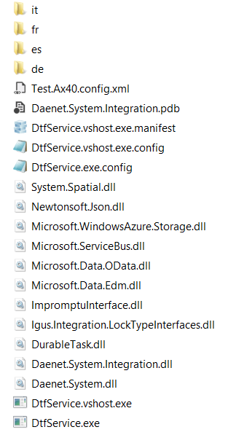

Then you should compile the MdmInterfaces project and copy the output dll and config (xml/json) to the deployment folder. For each interface (orchestration) there should be one configuration. For example Test.Ax40.config.xml or Test.Ax40.config.json. Maybe you have to run the TestHost project which creates the configuration files.

Now you should install the service with the installservice.bat file.

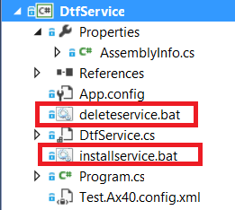

*Installservice.bat LockType "C:\ProgramFiles\Daenet\LockTypeProcess\dtfservice.exe" "LockTypeprocess interfaces hello"*

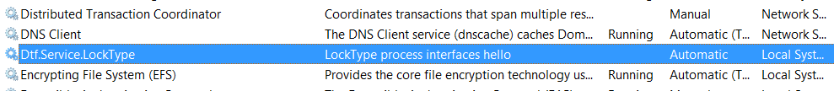

To uninstall service use deleteservice.bat batch file.

Example: *Deleteservice LockType.*

THIS IS THE OLD INSTALLATION DESCRIPTION:

Set of interfaces which implement one process should be deployed as a single application.  
For example you can implement multiple interfaces in one project. Logically it would be reasonable to implement in one project (one Assembly) only interfaces which belongs to the same business process.  
Physically, you can put any number of interfaces in a single assembly.

Then create the deployment folder and copy output of DtfService into it. You have to copy assembly implementation in the same folder where DtfService.Exe is copied.

Additionally, for each microservice (interface = orchestration) one configuration file *.config. In this example, this is Test.Ax40.config.xml.



To install the service use installservice.bat file



*Installservice.bat LockType "C:\ProgramFiles\Daenet\LockTypeProcess\dtfservice.exe" "LockTypeprocess interfaces hello"*



To uninstall service use deleteservice.bat batch file.

Example: *Deleteservice LockType.*

# All other stuff